Project: Visualizing Loan Data

Complete each section. When you are ready, save your file as a PDF document and submit it here: [https://classroom.udacity.com/nanodegrees/nd008/parts/c7cbb25d-deae-4be1-bc9c-71f465b849f8/project#](https://classroom.udacity.com/nanodegrees/nd008/parts/c7cbb25d-deae-4be1-bc9c-71f465b849f8/project)

# Step 1: Data Cleanup and Attribute Selection

*Clean up any missing information and choose the most important attributes you will explore further in your visualizations. List out the attributes (or variables) you plan to dive further with your visualizations. You should explore no more than 8 attributes. Please refer back to the* [*Data Cleanup course*](https://classroom.udacity.com/courses/ud977) *to help you clean up your data.*

There Are 3 Main Question that we need to answer:

1. How do the attributes differ between borrowers who pay back their loans versus those who don't?
2. How do accepted and rejected loan data differ among different locations?
3. How have issued loans changed over time?

I would like to use 8 attributes that I would like to explore:

1. Loan Amount
2. Grade & Subgrade
3. Employment Length
4. Home Ownership
5. Issued Date
6. Loan Status
7. Purpose
8. Address State

# Step 2: Tableau Visualizations

Please make sure you follow the [rubric](https://review.udacity.com/#!/rubrics/329/view) and include Tableau Dashboards, Stories, and the appropriate visualizations (small multiples, scatter plot, bar chart, etc..) your reviewer expects your visualizations to contain.

Attach your visualizations as Tableau Workbooks in a zip file along with this report.

**IMPORTANT**: Please save the workbooks as **Tableau Public** workbooks to allow reviewers to access your workbooks.

# Step 3: Questions

*Answer the following questions. Refer to your online visualizations to back up your answers.*

1. How do the attributes differ between borrowers who pay back their loans versus those who don't?
   1. **Bonus Question**: If there are any differences between certain attributes, are the attributes statistically significant? A [t-test](https://en.wikipedia.org/wiki/Student%27s_t-test) or [mann-whitney-u](https://en.wikipedia.org/wiki/Mann%E2%80%93Whitney_U_test) test could help answer this question.

In question 1 we will check the differences of borrower who pay back vs who don’t using 3 attributes:

1. The term
2. Grade
3. Purpose

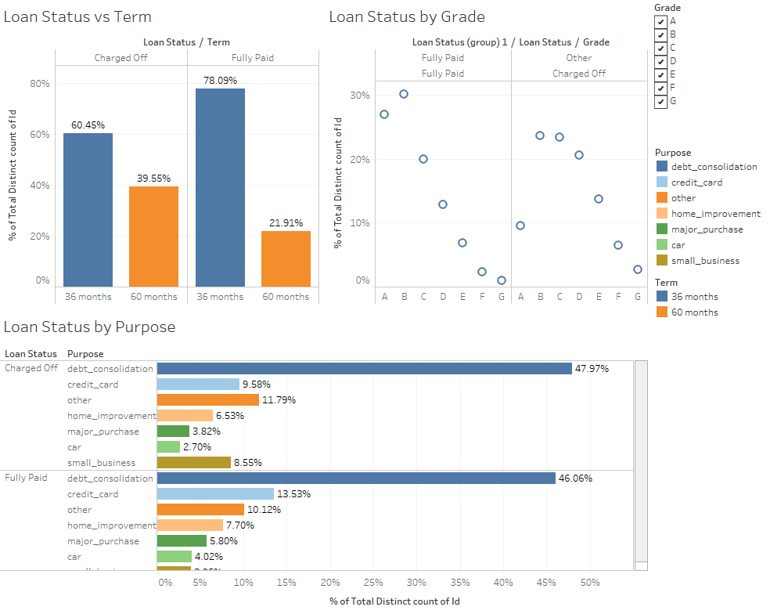

1. Charged off loan at 60 month term (39.55%) is higher than the fully paid loan at 60 month (21.91%), this means the longer term has higher risk at increasing charged off rate. We would need to do statistical test to assure this is statistically significant
2. Fully Paid Loan has higher percentage in A, B grade , then lower in trend compared by Charged Off Loan which have higher percentage in C,D,E,F&G compared by Fully Paid Loan.
3. The proportion of charges is higher than fully paid for loans used for small business purposes

**Question 2 :** How do accepted and rejected loan data differ among different locations?

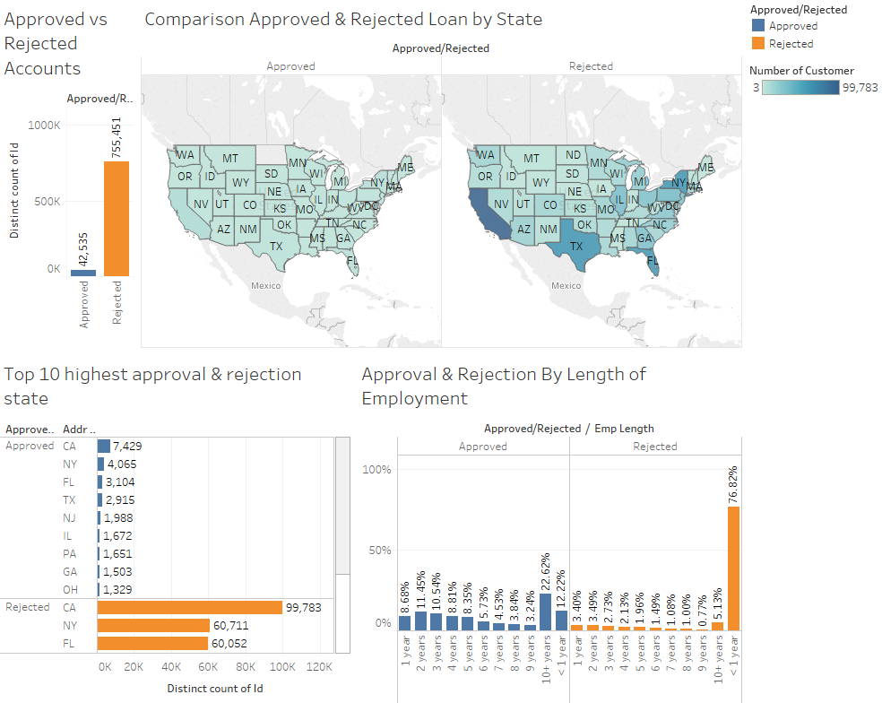

Ref: Check Dashboard Q2. Approved and Rejected Loan by State

* Trend of approved and rejected loan similar across the state, the top 10 state of rejected loan is similar to top 10 state of approved loan (check references because the snapshot was cut)
* The approved has higher percentage in length of employment 10+ years, and many of the rejected loan came from applicant who work less then a year (76,82%), but the rejection rate drops significantly after 1 year working experience

Question 3: How have issued loans changed over time?

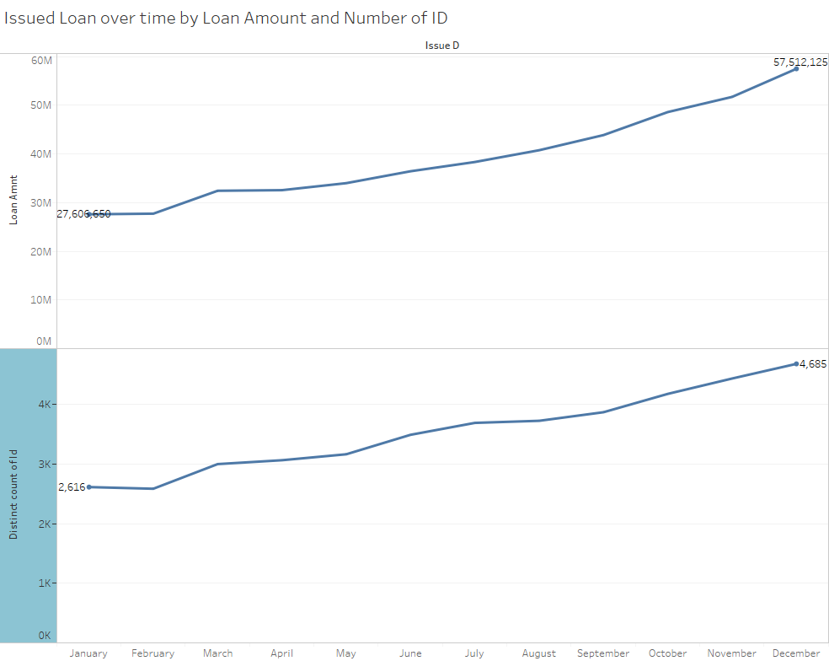

The amount of funded loan’s more than doubled during 2016, from around 27 million loan to 57 million at the end of the year of 2016. The number of customer also increased from 2616 at the beginning of the year, to 4685 at the end of the year. This also shows that the average of amount funded per customer was slightly increasing in 2016

1. What is your additional question that you proposed? What is the answer? How did you come up with this question?

What is the typical customer of Lending Club?

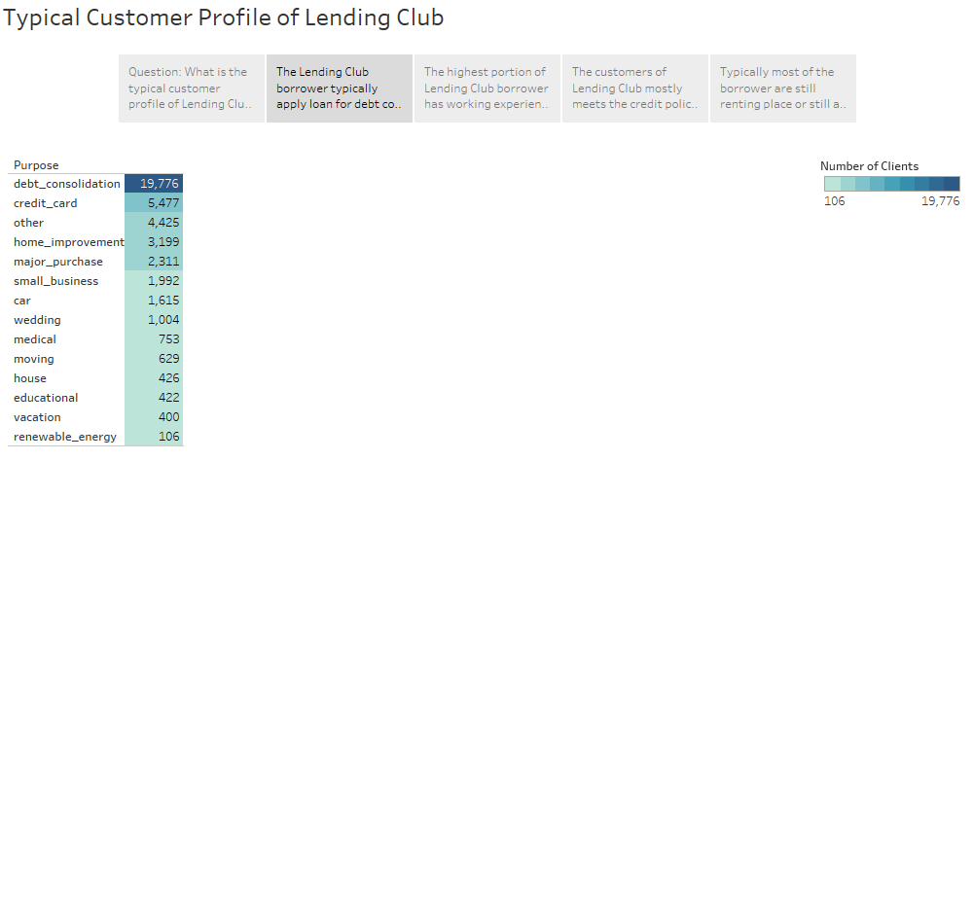

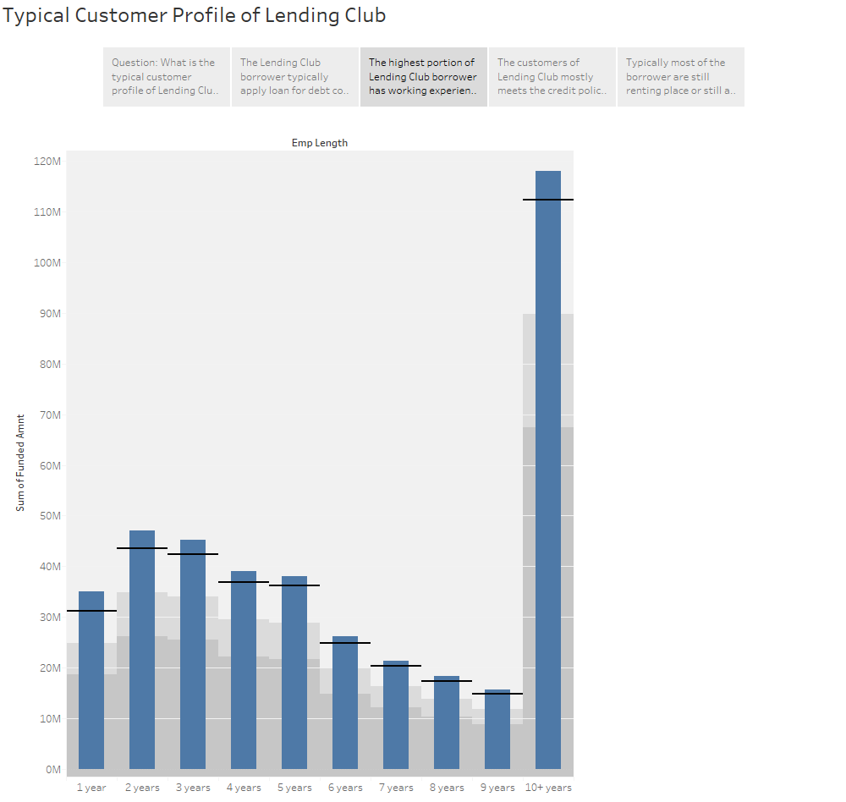

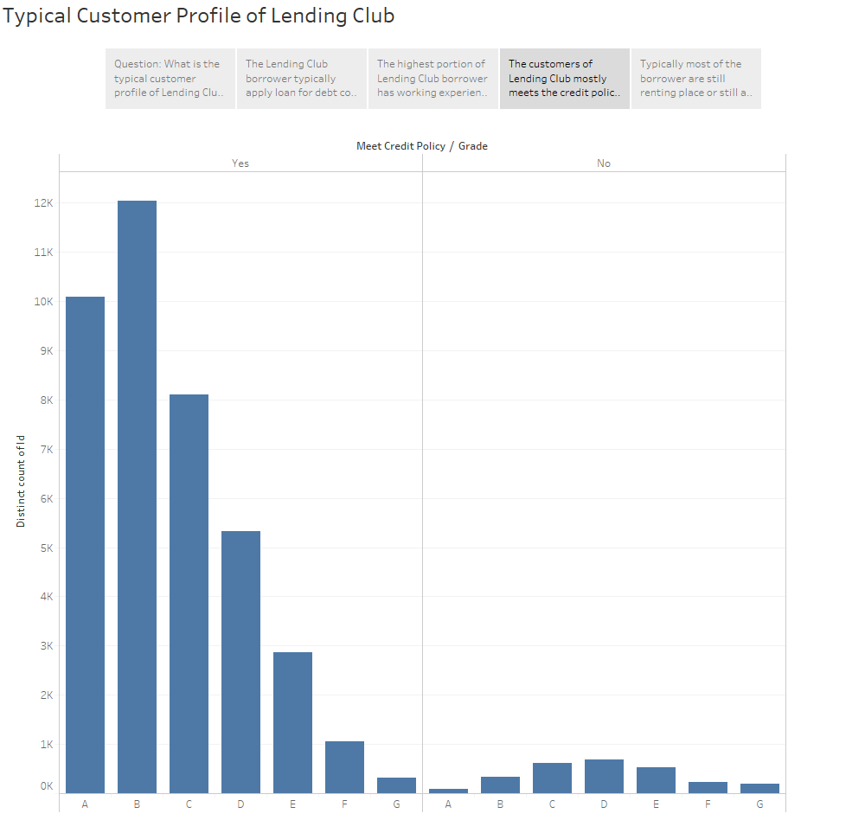

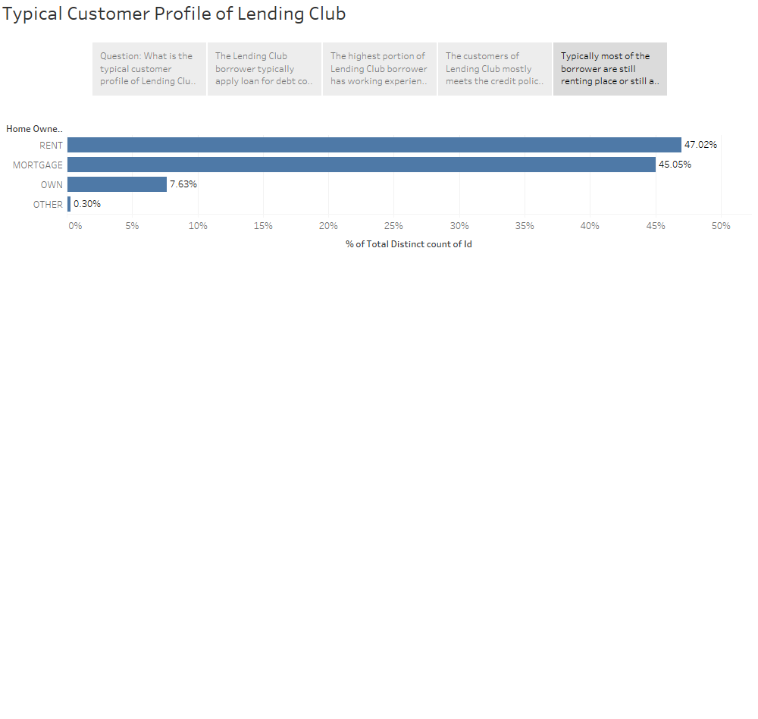

* Lending Club Approved clients are mostly applying for loan for Debt consolidation, followed by credit card purpose.
* Most of the clients are either renting place or currently on mortgage. It is very few loan applicants that own their own home.
* And the trend for the loan applicant employment work history increasing in trend from 1 to 5 years working experience, then the loan declining at 5-9, but there’s very high loan applicants who own working experience over 10 years+ .This may help segmenting the market whereas we can divide the market segment using age of 10+ working experience as primary target market and 2-5 years working experience as secondary target market

Tableau public references

<https://public.tableau.com/profile/hernando4174#!/vizhome/LendingClub-HernandoA_W_Renv2/Story1>

Hernando Andrianto Willy Ren

Hope it helps ! :D